Part I: Working on your own…
Connect the dotted lines. How many triangles can you find? How many quadrilaterals can you find? How many pentagons? In the table below, record the letters of the points that make up all the polygons that you can find.
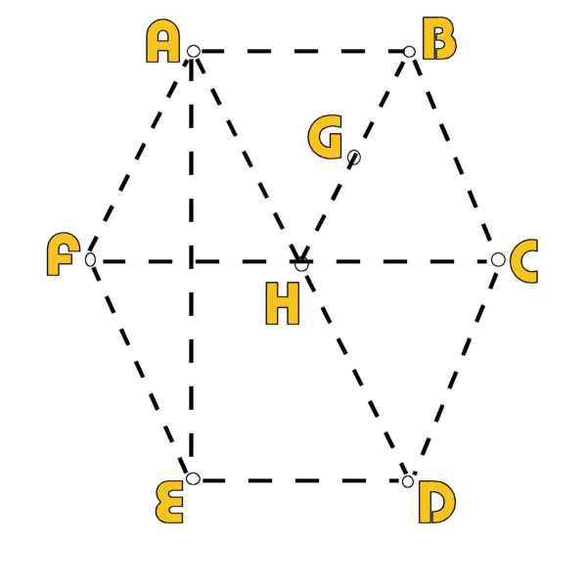 | Triangles | Quadrilaterals | Pentagons
 |  |  | 

Part II: Working in your pairs (1 & 3, 2 & 4)…
Compare your list with your partner. If your partner has a polygon that you missed, ask your partner to show you where it is on your diagram, and then record the points in the proper column of your table.

Part III: Working individually, then paired, then squared (Draw-Pair-Square)…
In the grid below: (1) Make your own “multiple-polygon” diagram and label the points. You should have at least 2 of each type of polygon. (2) Swap sheets with your partner and then add two more polygons to their diagram. (3) Square up with your group and trade sheets so that every Square member can find the all the polygons from another group member.
(1) Draw - (2) Pair |  |  |  |  |  |  |  |  |  |  |  |  |  |  |  |  |  |  |  | (3) Squared-Swap
Triangles

Quadrilaterals

Pentagons

