Media and Its Influence Karen Marlett and Nancy Paton

Grade 8 Language Arts Unit 10 lessons x 40 min

Overall Goals:
- Practice critical thinking skills to decode advertising.
- Form your own opinion about what advertising tells us about our culture and times.
- Learn the creative way advertisers use words, images, and sound to establish mood and persuade viewers to buy products.
- Work alone and in a group to use advertising techniques to create ads.

IRP’s:
Comprehend and Respond (Engagement and Personal Response)
- Make connections among different texts and media by comparing features, including themes, issues, styles, and appeal
- Describe and give examples to explain their personal criteria for assessing and responding to what they view, read, or hear

Comprehend and Respond (Critical Analysis)
- Identify and discuss various persuasive and advertising strategies
- Identify and discuss the advantages and limitations of a variety of media and explain their effects on people’s behaviour
- Identify bias and false reasoning in communications as these relate to their contexts

Communicate Ideas and Information (Composing and Creating)
- Compose or create works of communication for specific audiences and purposes, including to entertain, persuade, or inform
- Identify the purposes and audiences for their communications

Communicate Ideas and Information (Improving Communications)
- Adjust their form, style, and language for specific audiences and purposes
- Practise, assess, and offer feedback on oral presentations-including informal speeches and debates-focussing on such features as the inclusion of appropriate introductions and conclusions, eye contact, and pacing

Self and Society (Personal Awareness)
- Explain how new information, language experiences, and technology have shaped their ideas, knowledge, and beliefs

Self and Society (Working Together)
- Use various strategies to prompt and support others
- Use various strategies to resolve conflicts, solve problems, and build consensus
- Evaluate group processes and their own contributions to them by using established criteria

Unit Overview:

Lesson & Time | Topic | Objective | Activities  & Strategies | Materials  & Resources | Assessment  & Criteria
1  (40min) | Introduction to Persuasive Techniques Through Advertising | Students will understand that the media in their own lives influences them.  Students will understand why teen culture is important to advertising agencies. | 10 sec Logo Quiz  Show part of video about the amount of money spent by teenagers, and when the MTV exec goes to the home.  Assign groups for project, in groups, complete worksheets. | Overheads of various commercial logos.  Frontline-“The Merchants of Cool” Video  Worksheet with questions to answer. | TV log for homework, due at end of unit. “That’s Not All Folks”  “Who’s Watching Who” Worksheet from video must be completed to leave class (Exit ticket)
2  (40min) | Camera Techniques in Advertising | Students will be able to describe how specific camera shots are linked to the goal of selling the product. | Read pp 44,45 of text.  Group work; make a collage on poster board. | Magazines,  Glue, Scissors,  Poster board,  Defining Moments textbook | Collage where they find the eight different camera techniques in magazines.
3  (40min) | Words in Advertising | Students will be able to identify and use the six types of words advertisers use to sell their product. | Read p.46 of text.  Individual work, write four ad slogans that use three different persuasive techniques. | Defining Moments textbook,  Pen,  Paper | Four slogans to be handed in at end of class or homework for next day.
4  (40min) | Sound in Advertising | Students will be able to identify specific sound techniques advertisers use to sell their product. | Report on TV commercials | Defining Moments textbook,  Video of TV commercials | Written report during viewing of TV commercials
5  (40min) | The Storyboard Technique | Students will be able to create their own persuasive ad idea using the technique of a storyboard. | Creating their own storyboards for selling of the product. | Paper, coloured pencils,  Defining Moments textbook, p.47, 52 | Storyboards will be due on the following Monday
6  (40min) | Our Own Ad Agencies | Students will understand how companies decide to pick a specific T.V. commercial to make. | Mock ad agency meeting in which students will pick the “best” storyboard to create their own TV ad. | Storyboards from previous homework assignments | Group work; how well do the students come to a decision about the Storyboards together?
7  (40min) | Behind the Scenes: How They Make Ads | Students will understand how much time, money and efforts companies spend on advertising. | Read pp.51-54 of text | Defining Moments textbook | Group work; how well do the students work together planning their commercials?
8  (40min) | Gender Stereotyping: Mooks and Sexpots | Students will understand how companies target males and females differently by trying to tell teenagers what is cool. | Create a typical male (mook) and female (sexpot) with labelled parts considered “cool” right now. | Frontline Video- “The Merchants of Cool”  Paper, coloured pencils, etc. | Labelled diagrams due the next day.
9  (40min) | Anti-Advertising Culture | Students will understand the existence of the anti-advertising culture. | Adbusters on overhead, talk about what they are saying about the original | Adbuster ads (overheads) | Written paragraph response to an Adbuster Ad that class has not talked about.
10  (40min) | Television Ad Presentations | Students will demonstrate their understanding of persuasive techniques used by the media by presenting their own unique T.V. commercial to the class. | Each group will give a TV commercial presentation to the class.  We will then debrief and talk about what we liked, why and the techniques used. | All the props they want to use for their presentations.  Group presentations assessment sheets. | Group presentation; both individual and group mark.

Who’s Watching Who? Name: _____________________

How much money do teens spend per year?___________________________________

Name three large companies mentioned in the video. ___________________________

__________________________________ ____________________________

Why are teens so important to companies? ___________________________________

______________________________________________________________________

______________________________________________________________________

______________________________________________________________________

What is a negative feedback loop? __________________________________________

______________________________________________________________________

Why does “cool” change constantly? ________________________________________

______________________________________________________________________

______________________________________________________________________
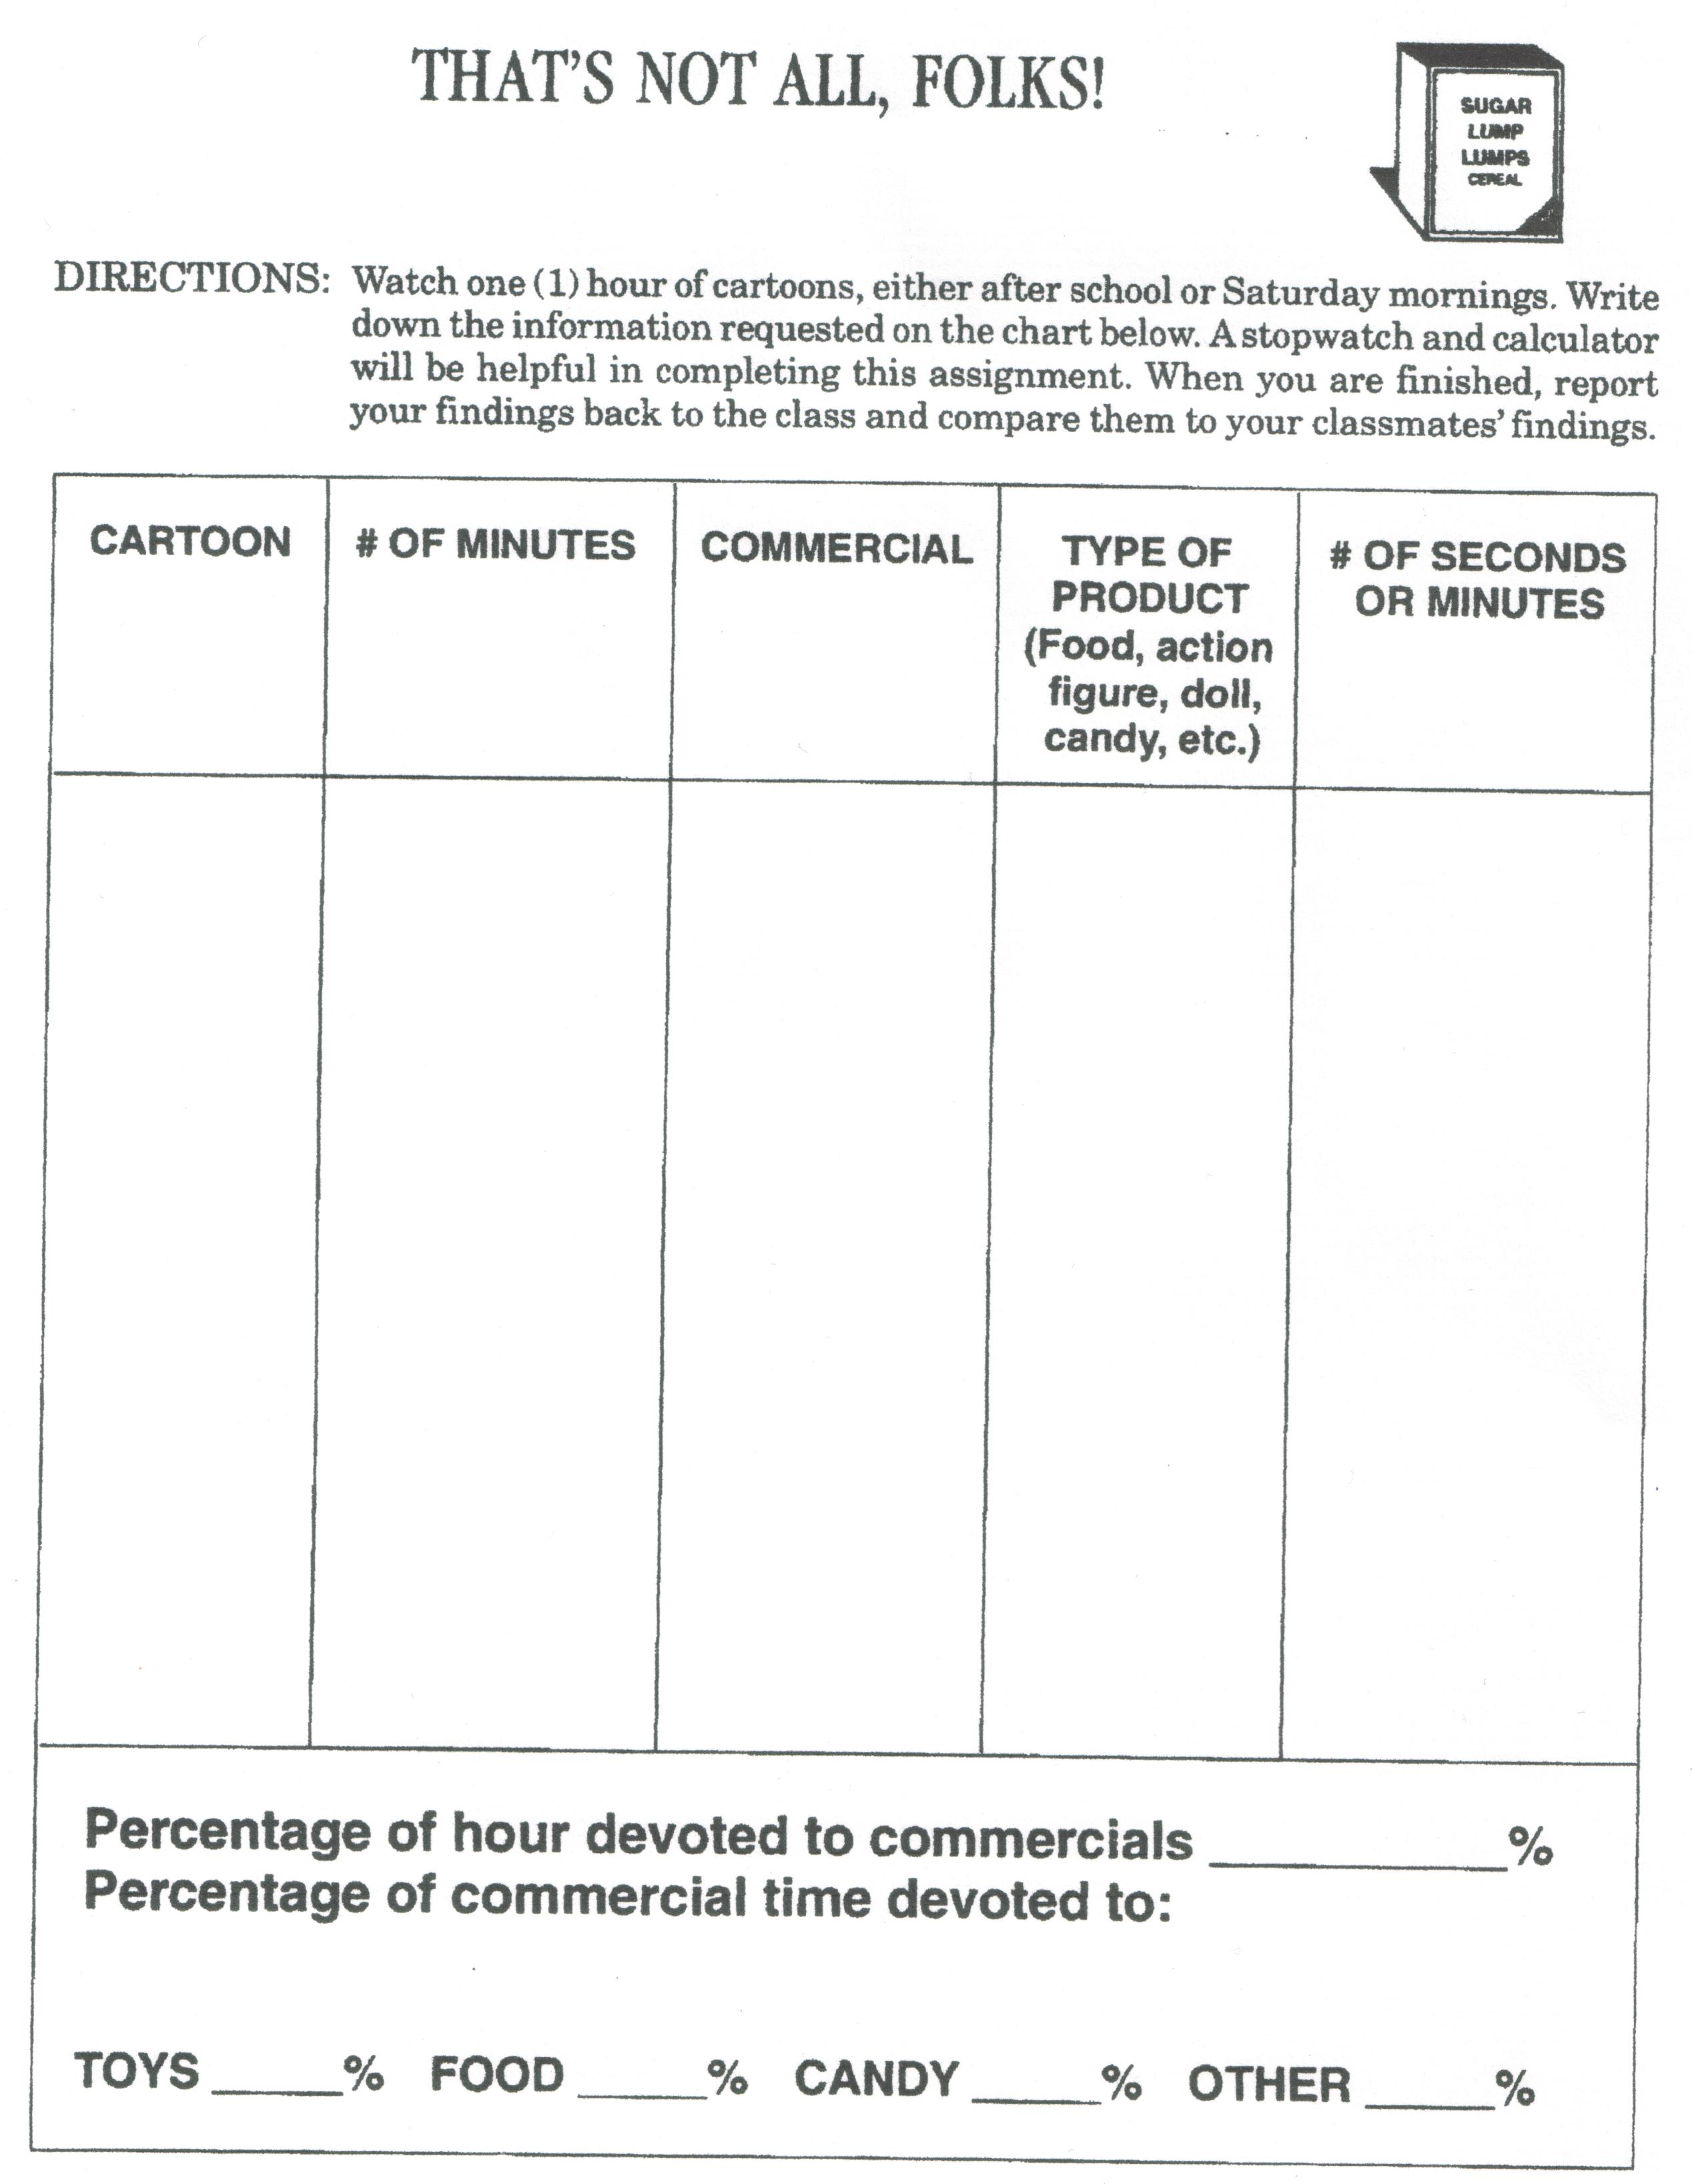
DAY 1: Introduction to Persuasive Techniques Through Advertising
(40 min)
*Remember to double-check attendance *
Instructional Objectives:

- Students will understand that the media in their own lives influences them.
- Students will understand why teen culture is important to advertising agencies.

Introduction:

- Students are influenced by media around them. We will give them an experience that shows them how strong this influence is.
Instructional Strategy:

- 10 second logo quiz
- put logos on overhead for 10 sec and get students to write on a piece of paper the name of the company and what they sell (5 min)

Body of the Lesson:

- Show how marketing companies are extremely interested in the teenager group of consumers so students can see how marketing research is targeted at THEM

- Explain the idea of a negative feedback loop

- Divide into project groups
Written response to video

Instructional Strategies:

- Frontline-“The Merchants of Cool” Video (15 min)

2) Teacher Talk explaining negative feedback loops with examples (ie: playing too many video games leaves no room for homework, eating too much Christmas food makes you feel sick) and then connect these ideas to the idea that exploiting “cool” kills “cool” (5 min)

3) “Who’s Watching Who” Worksheet

Closure:

- Restatement of two objectives of lesson.
.
Instructional Strategies:

- Debrief and worksheet is their exit ticket or must complete for homework

Assessment & Evaluation:

- “That’s All Folks” T.V. log, due at end of unit
- “Who’s Watching Who” Worksheet, due end of class (Exit ticket)

Materials:
- 15-20 various logos on coloured overheads (Starbucks, McDonalds, Ikea, etc.)
- Frontline-“The Merchants of Cool” Video
- TV Log- “That’s Not All Folks”
- “Who’s Watching Who” Worksheet

Adaptations:

- (Block 1&2) - Make sure each ESL student understands what to do.
(Ahmad, Jun, Seung, Gilbert)

- Watch Ed and Jordan

- (Block 3&4) - Make sure each ESL student understands what to do.
(Daniel, Mike, Jonathan)

- Martha will work with Lindsay (totally different lesson)

- Watch Dennis

- Notes to Nick and Jesse

- Wear FM receiver for Doug

Teaching Tips/Notes:

Lesson 2: Camera Techniques in Advertising

Goals:

- Students will be able to describe how specific camera shots are linked to the goal of selling a product.

Materials:

- Textbook- Defining Moments
- Definitions worksheet
- 10 pieces of poster board
- Glue
- Markers
- Scissors
- Magazines
- Colored overheads of two opposite ad examples (Hook)

Introduction: (5 min)

- Show two different ads on the overhead of similar products (eg: cars), that uses different camera angles, lighting techniques or distances.
- Ask students which product they would purchase and why.
- Have a short discussion why they chose that product and why.

Questions to help facilitate discussion:

- Is there any reason you find one product more appealing than the other?
- Can you identify any differences between the ads? (ie: color)
- How does each of the two ads make you feel as a consumer?

Body of Lesson: (30 min)

- Guided reading of pp. 44-45 in text. Get students to follow along.

- Pass out definitions sheet. Allow students to work together with the person beside them to complete the sheet.

- Go over the answers to the worksheet.

- Use “random paper picking method” to establish groups of three. Remind students that they are being marked on how well they cooperate with each other throughout this unit. One student will be the ad searcher, one will be the team leader and tidier, and the other will be the poster designer.

- Show example of what the poster should look like. (One example of low angle, high angle, straight on angle, close-up, medium distance, long distance, high key lighting, low key lighting)

Closure: (5 min)

- Bring class back to attention.

- Hand out ad assignment. For homework, they are to hand in a paragraph about the ad that includes the camera angle technique, and why the ad agency chose this particular one.

- Work area must be tidied before the groups can leave.

Assessment:

- Students demonstrated an ability to recognize and identify different camera angle techniques used in advertising through discussion, individual ad assignment, and group collage.

- Groups will be assessed on the social responsibility rubric.

Adaptations:

- (Block 1&2) - Make sure each ESL student understands what to do.
(Ahmad, Jun, Seung, Gilbert)

- Watch Jordan

- (Block 3&4) - Make sure each ESL student understands what to do.
(Daniel, Mike, Jonathan)

- Martha will work with Lindsay (totally different lesson)

- Watch Dennis

- Notes to Nick and Jesse

- Wear FM receiver for Doug

Teaching Tips/Notes:

CAMERA TECHNIQUES IN ADVERTISING
pp. 44-45 of Defining Moments textbook

Camera Angles

Low Angle:___________________________________

_____________________________________________

High Angle:_______________________________________________________

_________________________________________________________________

Straight On Angle:__________________________________________________

_________________________________________________________________

Distance

Close Up:_________________________________________________________

_________________________________________________________________

Medium:__________________________________________________________

_________________________________________________________________

Long:____________________________________________________________

_________________________________________________________________

Lighting

High Key:_________________________________________________________

_________________________________________________________________

Low Key:__________________________________________________________

__________________________________________________________________

Colour ____________________________________________________________

___________________________________________________________________

So…We’re Making a Commercial

You are now part of an Ad Agency.

- The person with the birthday closest to January 1st is the Company President. The presidents’ job is to run the meeting, call the vote, and make sure discussion stays on task. You want your company to sell the most product and make the most money because that mean YOU make money.

2. The person with the next closest birthday is the Company Secretary. The
secretary’s job is to write down all the ideas your company comes up with. You
will write down the parts of the storyboard you need to make up the commercial,
and any other ideas your group discusses so that you remember every detail.
YOU want a raise, and the more you write down, the better chance you have to
bget it.

- The person in the group with the birthday closest to December 31 is the
Company Technician. The company technician is an expert on camera angles, lighting techniques, colour, camera distance, sounds, and advertising claims. This
person also wants a raise, and the more ideas they can come up with from (ahem, cough) their NOTES, TEXTBOOK, the better.

- Decide on which storyboard you will make into a commercial.
- Make sure you look at the company statement and target audience. Decide as a group which idea will make the best commercial.
- Have a vote (if you have to) in order to decide.

