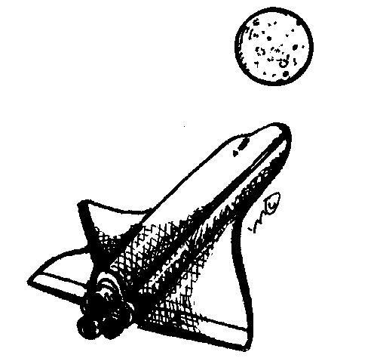

Exploring Space
- A Mini Unit

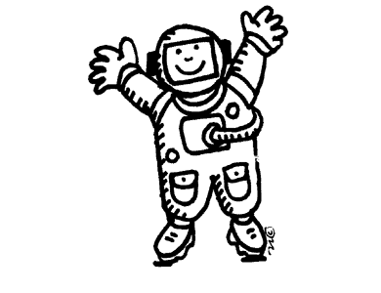

Grahame Quan
Sced 320
Assignment C
02.23.03

grahame quan
sced 320
assignment c

Unit Overview

Prescribed Learning Outcomes Covered in this unit:
(Earth Science Grade 6 (Solar System & Space Exploration) – p. 114 Science K-7 Integrated Resource Package)

- Outline the history of piloted and unpiloted flight.
- Identify the human and technological requirements for space exploration.
- List the contributions that space exploration has made to everyday life.
- Describe the primary features of our solar system.
- Compare and contrast the conditions that support life on Earth with those of other planets and our moon.
- Relate the movement of the sun, moon and Earth to seasons, tides, eclipses, and the phases of the moon.

The Key concepts covered:

- History of human perception of the solar system – Ptolemy, Copernicus, telescopes, satelites and space exploration
- The Solar System – The Sun and its planets
- Movement of the Sun, Earth and Moon
- Survey of history of piloted and unpiloted flight
- Technological and Human requirements for Space exploration
- Contributions of space exploration to everyday life

Rationale Statement:

The lessons in this unit incorporate a variety of teaching approaches that will accommodate a diverse group of learning styles.

- Visual and non-visual instruction
- Teacher led activities
- Constructivist student centered activities
- Individual and group activities
- Student researched projects and presentations

Overall Assessment Plan

Component | Assessment Method | Component Weight
#1- Introduction to studying Solar system | Worksheet | 6.25%
#2 – Solar system | Worksheet | 6.25%
#3-4 – Traveller’s guide to the Solar System | Travel Brochure Project | 6.25%
#5 Phases of the moon | Worksheet | 6.25%
Solar System Quiz (btw Lesson 5&6) | Quiz (Summarizing Lessons #1-4) | 15%
# 6 History of flight | Worksheet  Group Skits | 6.25%
#7 Human and technological Requirements for space exploration | Group Presentation and Spacecraft Design | 6.25%
#8 Human and technological Requirements for space exploration | Individual Spacecraft Design | 6.25%
#9 Space exploration contributions to everyday life | Worksheets | 6.25%
Space Exploration Quiz | Quiz (Summarizing Lesson #5-9) | 15%
Student Effort Mark | Student Effort Mark  - All assignments complete  - Work ethic  - Participation | 20%
Space Mini Unit TOTAL | ----------------------------------- | 100%

Unit Plan

Lesson 1: Introduction to studying our Solar system

Hook:

Is the Sun really the centre of our solar system – Why is the Earth not the Centre of the universe

Introduce Greek belief that the Sun was the shield of Apollo racing across the Sky.
Ptolemy believed that the Earth was the centre of the universe
Copernicus challenged this notion in 16th Century
Discuss celestial bodies and what can be seen and the idea of perspective
Discuss the changing notion and the current conception.
PLO’s

- Describe the primary features of our solar system
- Relate the movement of the sun, moon and Earth to seasons, tides, eclipses, and the phases of the moon

SWBAT look at visual images of features of the solar system of different perspectives and identify the features in worksheets.

Activity

Students are to divided into groups and presented a series of images.
Groups will be given images with differing perspectives – eye view photos, modern telescope photos, satellite telescope photos.
They are to deduce what the objects are – Satellite? Planet? Star? Comet?
Write in worksheets – what are the objects, how far away are they?
Present to class what they see. Compare with other groups.

Closure: Emphasis on different perspectives and technology allowing certain perceptions of celestial bodies.

Materials:

Images, worksheets.

Assessment: Worksheets that label celestial bodies and technology used to identify.

Resource Reference for celestial images: http://cse.ssl.berkeley.edu/SegwayEd/lessons/BOSS/lessonplan2.htm

Lesson 2: Our Solar system – Identifying the Sun, the planets.

PLO Describe the primary features of our solar system

SWBAT learn about the features of the solar system and the relative positions of the planets by laying out models planets and presenting information on their planet. This will accommodate visual, individual and group learners with the activity strategies.

Activity: Students divided into 11 groups
Each group given research materials.
Need to fill out activity sheet describing features of designated body (The Sun, Mercury, Venus, Earth, Mars, Asteroid belt, Jupiter, Saturn, Neptune, Uranus and Pluto.)
Groups are to lay out a drawn model to represent on floor to represent relative position in solar system and teach other students about their body. Other students fill out worksheets based on other groups presentations.

Materials: Research Material, Worksheets.

Assessment: Presentation and worksheets.

Lesson: Movement of the planets, sun. moon

Lessons 3&4: Further investigation of our solar system - A Traveller’s guide to the Solar System.

PLO -Describe the primary features of our solar system
-Compare and contrast the conditions that support life on Earth with those of other planets and our moon

SWBAT design and construct a travel brochure explaining the features of the planet and what there would be to see as a tourist.

Activity:
Students are individually assigned one of the featured bodies of the solar system.
Students are given one class period to research further information at library and internet on their planet, the asteroid belt or Sun.
Students are to design and construct a travel brochure explaining the features of the planet and what there would be to see as a tourist.
Students are to use comparisons of the life supporting conditions of the Earth with the planet that they are promoting.

Materials:
Library Resources, Computer Lab time (needs to be booked), Construction paper.

Assessment: Travel Brochure

Lesson 5: Phases of the moon

PLO: Relate the movement of the sun, moon and Earth to seasons, tides, eclipses, and the phases of the moon.

SWBAT draw the different phases of the moon and relate its visual appearance as viewed from the earth to its actual relative position to the sun and earth.

Activity: Ask about students interpretation of why there are different phases of moon
Demonstrate phases of moon with model moons and projector as sun.
Students draw out phases.

Materials: Styrofoam moons, overhead projector.

Assesment: Students to draw diagram of phases of moon and illustration to explain how the phases are caused by moon’s position relative to earth and sun.

Lesson 6: A history of flight

PLO Outline the history of piloted and unpiloted flight

SWBAT learn about some of history of piloted and unpiloted flight by role playing skits to retell the stories.

Activitity:
Show blooper video of attempts at flight –flying machines.
Students divided into 7 groups
(DaVinci flying machines, Hot Air Balloons, Wright Brothers 1st flight, Jets, Sputnik, Apollo, Space Shuttle)
Groups to do random ordered role-playing skits about the events.
As a class – students to decide correct timeline of events.

Materials:
Scenario cards, worksheets

Assessment:
Worksheets, Presentation of skits, class discussion of events.

Lesson 7-8: Identify human and technological requirements for space exploration.

PLO: Identify the human and technological requirements for space exploration

SWBAT design spacecraft that incorporate some of the human and technological requirements for space travel.

Activity:

Lesson 7

Class begins with a discussion of what human and technological requirements would be needed in order to design a space craft to travel to Mars.
After main ideas are identified – students divided into groups and design a spacecraft that addresses requirements discussed.
Groups present their designs to class.
Closure discussion – discuss technological problems for requirements, different solutions to problems.

Lesson 8

Based on ideas presented in class, individual students design their own spacecrafts
incorporating ideas from class.

Materials:
Large sheets of paper, markers, large diagrams of space shuttle and space stations.

Assessment:
Presentation of group spacecraft design, individual spacecraft design.

Lesson 9: How space exploration contributes to everyday life.

PLO: List the contributions that space exploration has made to everyday life.

SWBAT identify products that were designed for space exploration that are used in everyday life.

Activity:

Students will go in groups to a series of stations.
At each of the stations will be a number of everyday products or pictures/photos of everyday items.
At stations groups will discuss what how they think the products were used in space and write down there reasoning in their worksheets.
At the end of the stations, the class will present their theories and then have it compared to the actual uses.

Materials:
Actual everyday products (eg. Tang, aluminum foil, athletic shoe shock absorption, cordless power tools, scratch resistant lenses etc.) and/or diagrams and photographs ( heart monitors, Firefighting gear), worksheet.

Assessment:
Worksheet and discussion.

